|  |
| --- |
| GAME NAME: Crown and Anchor Game |
| EXAMINER: Hung Ngoc NGUYEN |
| DATE: 20/10/2017 |

TRACING BUG 2- DICE REPETITION

1. DICES WAS NOT CHANGED RESULT:

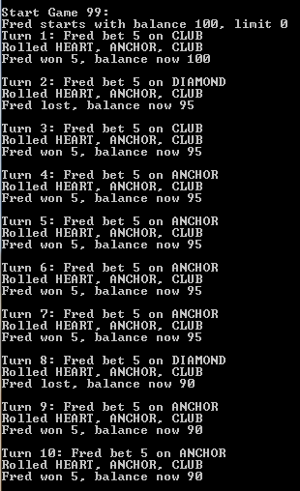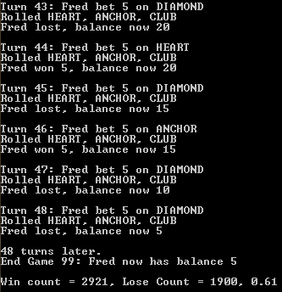

1. Initial bug, /4-Resolution (source)/Main.java, line 10

The dice should place inside the while loop to ensure that the values of the dice change every turn.

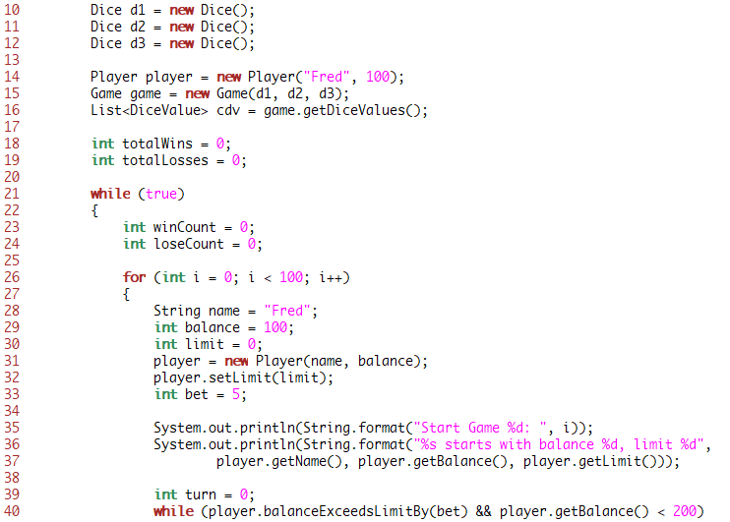

1. Resolved bug, /4-Resolution (source)/Main.java, line 42

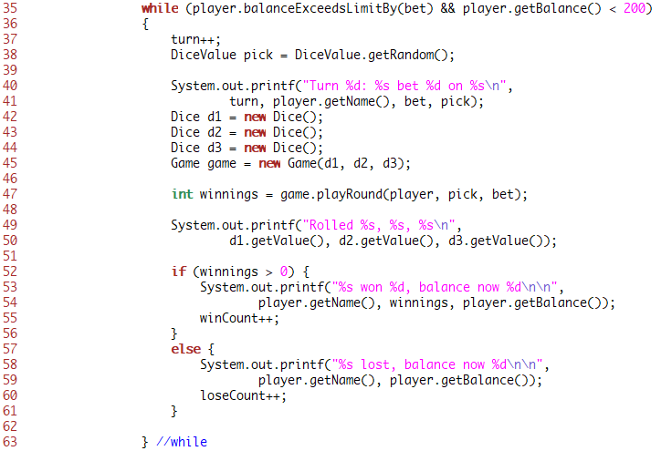

1. Output after changed codes:

